# Software engineering project

**SOLAR PLANT**



**FINAL REPORT**

[Md Farukul Islam](https://omega.cc.puv.fi/redmine/users/340) e1701764

[Albin Westerlund](https://omega.cc.puv.fi/redmine/users/337) e1701460

Carlos Martínez de la Riva Valdaliso e1901280

Contents

Contents 2

1 Introduction 3

1.1 Description of the Project 3

1.2 Project Objectives 3

1.3 Right to the Deliverables of the Project 3

2 CUSTOMER, PROJECT, MAIN TASKS 4

2.1 Customer 4

2.2 Project 4

2.3 Main Tasks 4

3 Team and RolEs 4

4 Background technology 4

5 The result 5

6 Installation Guide 10

7 Grading between student 11

8 CONCLUSION 12

# Introduction

## Description of the Project

The solar energy sector is increasingly expanding in Finland because the sun does not set in summer. So many hours of daylight, coupled with the fact that solar panels increase their efficiency at low temperatures and clean environments, make Finland a perfect site for solar energy production.

In our case, we have solar panels managed by Vacon 8000 Inverter of maximum production 5 kW, located in the Technobotnia building.

The main objective of this project is the design and development of a dashboard that collects information related to the solar production of the plant. The user will be able to see real-time data as well as the monthly production or the estimated production based on the weather forecast for the next 24 hours.

## Project Objectives

The main objectives of the project are as follows:

* Show information related to daily solar production.
* Show monthly and annual production.
* Display previous 24 hours production.
* Display estimated production for next 24 hours (depending on weather forecast).

## Right to the Deliverables of the Project

All rights will belong to VAMK. For educational purposes, never for commercial purposes.

**2 Customer, project, main tasks**

**2.1 Customer:**

Timo Kankaanpää

**2.2 Project:**

Solar power plant

2**.3 Main Tasks:**

Designing an iot-ticket based monitoring dashboard for solar power plant.

# client and Team members

|  |  |
| --- | --- |
| Team Member Name | Roles |
| Md Farukul Islam | Project Manager and developer |
| Albin Westerlund | Team Leader and developer |
| Carlos Martinez de la Riva Valdaliso | Team member and developer |

# Background technology

Vacon 8000 Solar Inverter

* 5 kW max.

WRM 247+

* Device for control and remote management of the solar plant
* We use WRM24/7+ for data acquisition

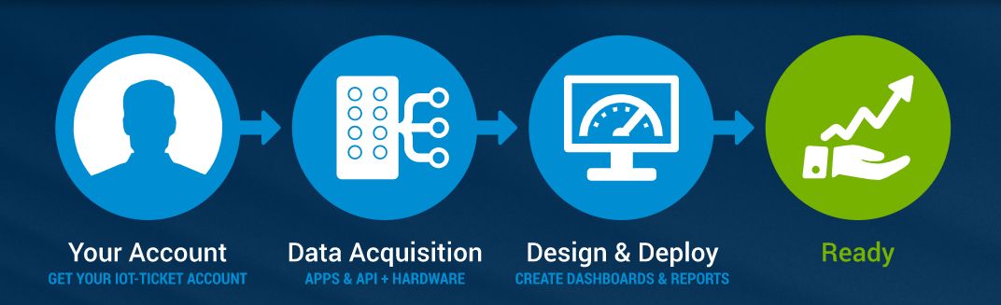

Fig1 : Iot-ticket Technology

IoT-Ticket.com

* We use iot-ticket.com for designing our application interface both for pc and mobile.

Rest Client

* It provides you to enter any URL and POST/PUT/DELETE to it
* We use python for fetching data

# The result

**Iot-Ticket Based Dashboard for Monitoring Solar Plant:**

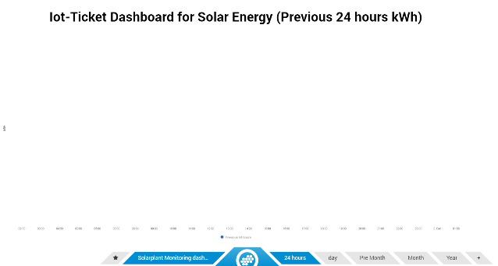

Fig 2: Iot-Ticket Dashboard for Solar Energy (Previous 24 hours kWh) interface design

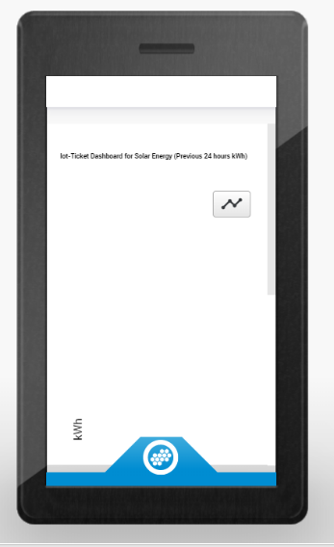

Fig 3: Iot-Ticket Dashboard for Solar Energy (Previous 24 hours kWh) Mobile design

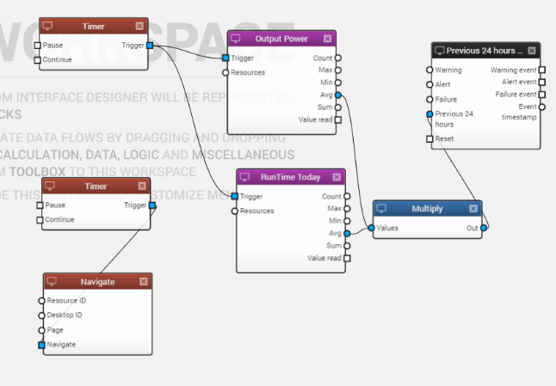

Fig 4: Iot-Ticket Dashboard for Solar Energy (Previous 24 hours kWh) dataflow design

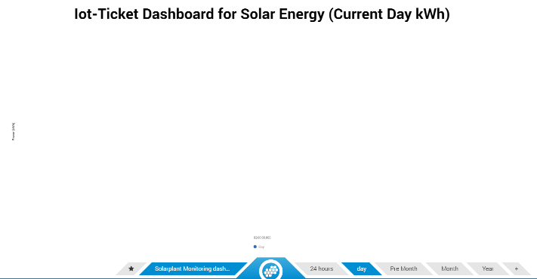

Fig 5: Iot-Ticket Dashboard for Solar Energy (Current Day kWh) Interface design

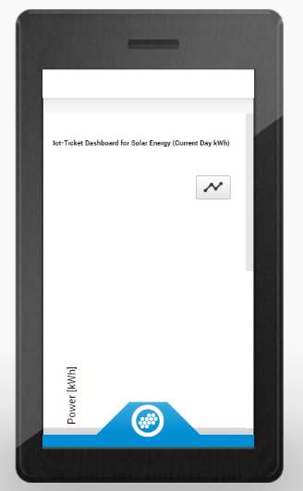

Fig 6: Iot-Ticket Dashboard for Solar Energy (Current Day kWh) mobile design

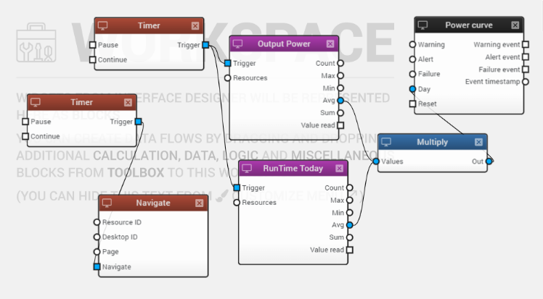

Fig 7: Iot-Ticket Dashboard for Solar Energy (Current Day kWh) dataflow design

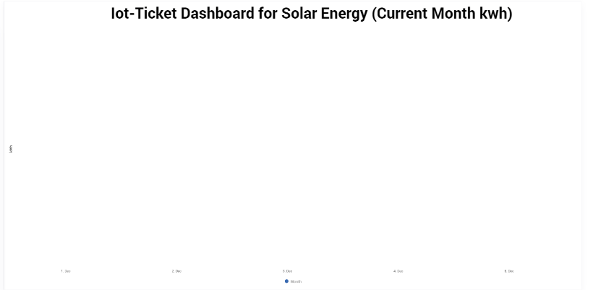

Fig 8: Iot-Ticket Dashboard for Solar Energy (Current month kWh) Interface design

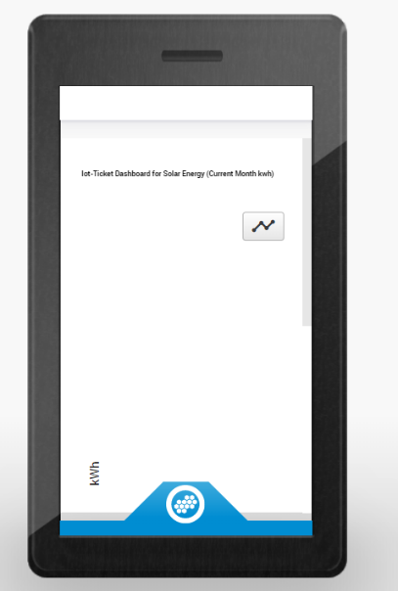

Fig 9: Iot-Ticket Dashboard for Solar Energy (Current month kWh) mobile design

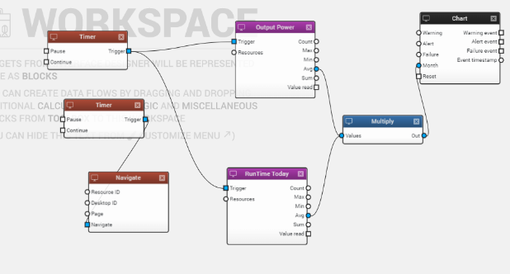

Fig 10: Iot-Ticket Dashboard for Solar Energy (Current month kWh) dataflow design

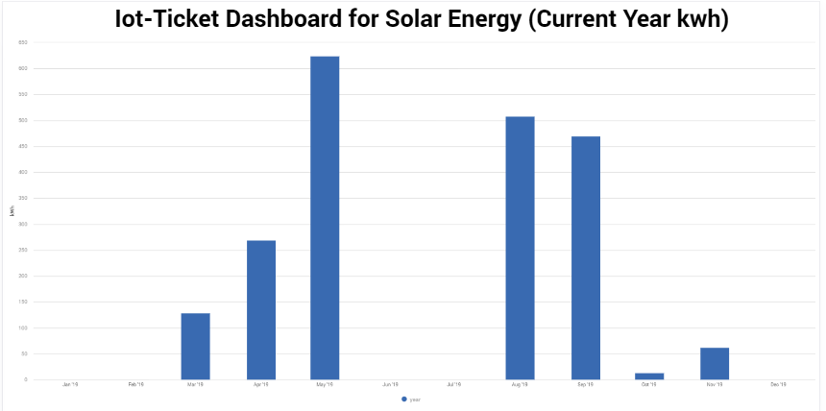

Fig 11: Iot-Ticket Dashboard for Solar Energy (Current year kWh) Interface design

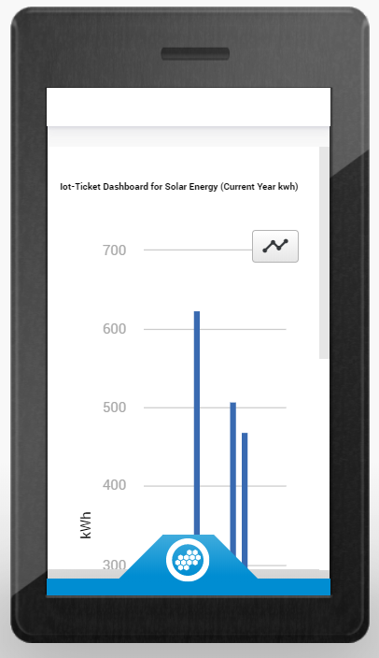

Fig 12: Iot-Ticket Dashboard for Solar Energy (Current year kWh) mobile design

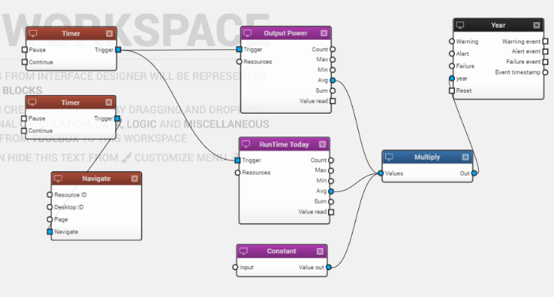

Fig 13: Iot-Ticket Dashboard for Solar Energy (Current year kWh) dataflow design

# Installation Guide

* Git link for project <https://git.vamk.fi/e1701764/iot_solarplant>
* For installing our apps doesn’t need to install any external module
* For running the apps first we need to go iot-ticket.com site. We need an access id and password for iot-ticket.com. Then from resource browser and then the desire device (vacon 8000 solar). Then select the designed dashboard name (Solar plant monitoring Dashboard).

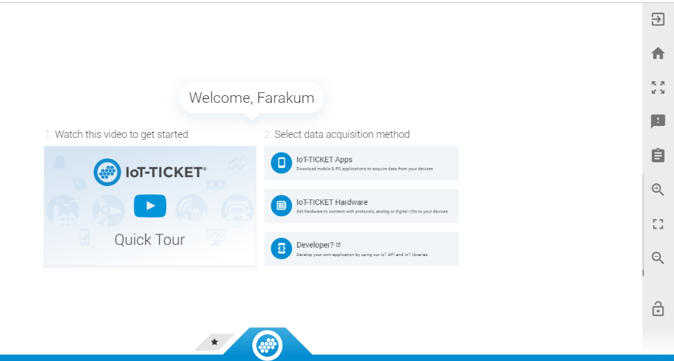

Fig 14: Iot-ticket.com welcome page

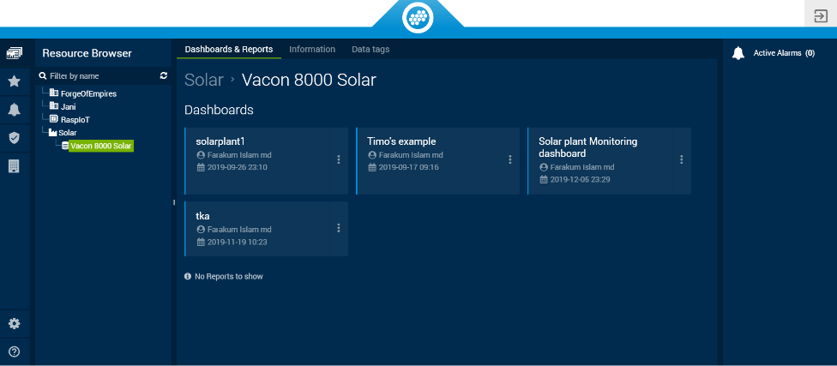

Fig 15: Iot-ticket.com our project page

* 4. The video link for how to run our application is <https://www.youtube.com/watch?v=y712tHdCPjQ&feature=youtu.be>

# Grading between student

[Md Farukul Islam](https://omega.cc.puv.fi/redmine/users/340)

* Project manager and developer
* Communicating with customers
* Designer and maintener

[Albin Westerlund](https://omega.cc.puv.fi/redmine/users/337)

* Developer
* Team Leader
* Tester

Carlos Martínez de la Riva Valdaliso

* Reporter
* Documenting requirements specification
* Documenting technical specification

|  |  |
| --- | --- |
| Team Member | Given Grade |
| Md Farukul Islam | 5 |
| Albin Westerlund | 5 |
| Carlos Martinez de la Riva Valdaliso | 5 |

# CONCLUSION

* Remote monitoring and control of assets
* Modern, easy to use, web-based UI
* Powerful report creation and analytics
* Big data enabled and inbuilt security

So, by using of IoT is proving to be beneficial for monitoring power generation from our solar plant.